|  |  |
| --- | --- |
| Course | Information Security |
| Assignment | Assignment 2 |
| Student ID | 100899259 |
| Student Name | Maisha Khatoon |

# 2A: Packet Tracer - Configuring ASA Basic Settings and Firewall Using CLI

We create the hostname and space names for the ASA physically, set up internal and external interfaces, NAT rules, access control records (leg tendons), design steering, address interpretation, review strategy, and create steering records. Using order line interface, configure DHCP, AAA, SSH, DMZ, Static NAT, and upper leg tendons (CLI). In this lab, I learned how to use the order line connection point to physically construct the basic configurations for a Cisco ASA and firewall.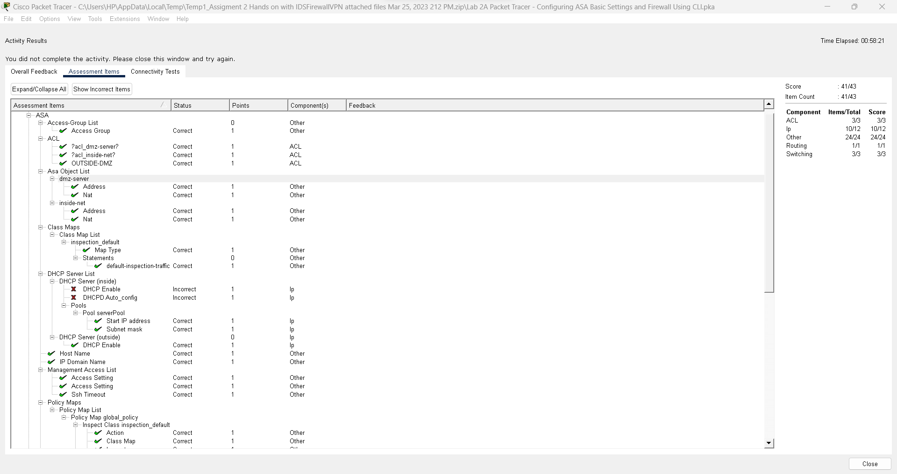

# 2B: Packet Tracer - Configure IOS Intrusion Prevention System (IPS) Using the CLI

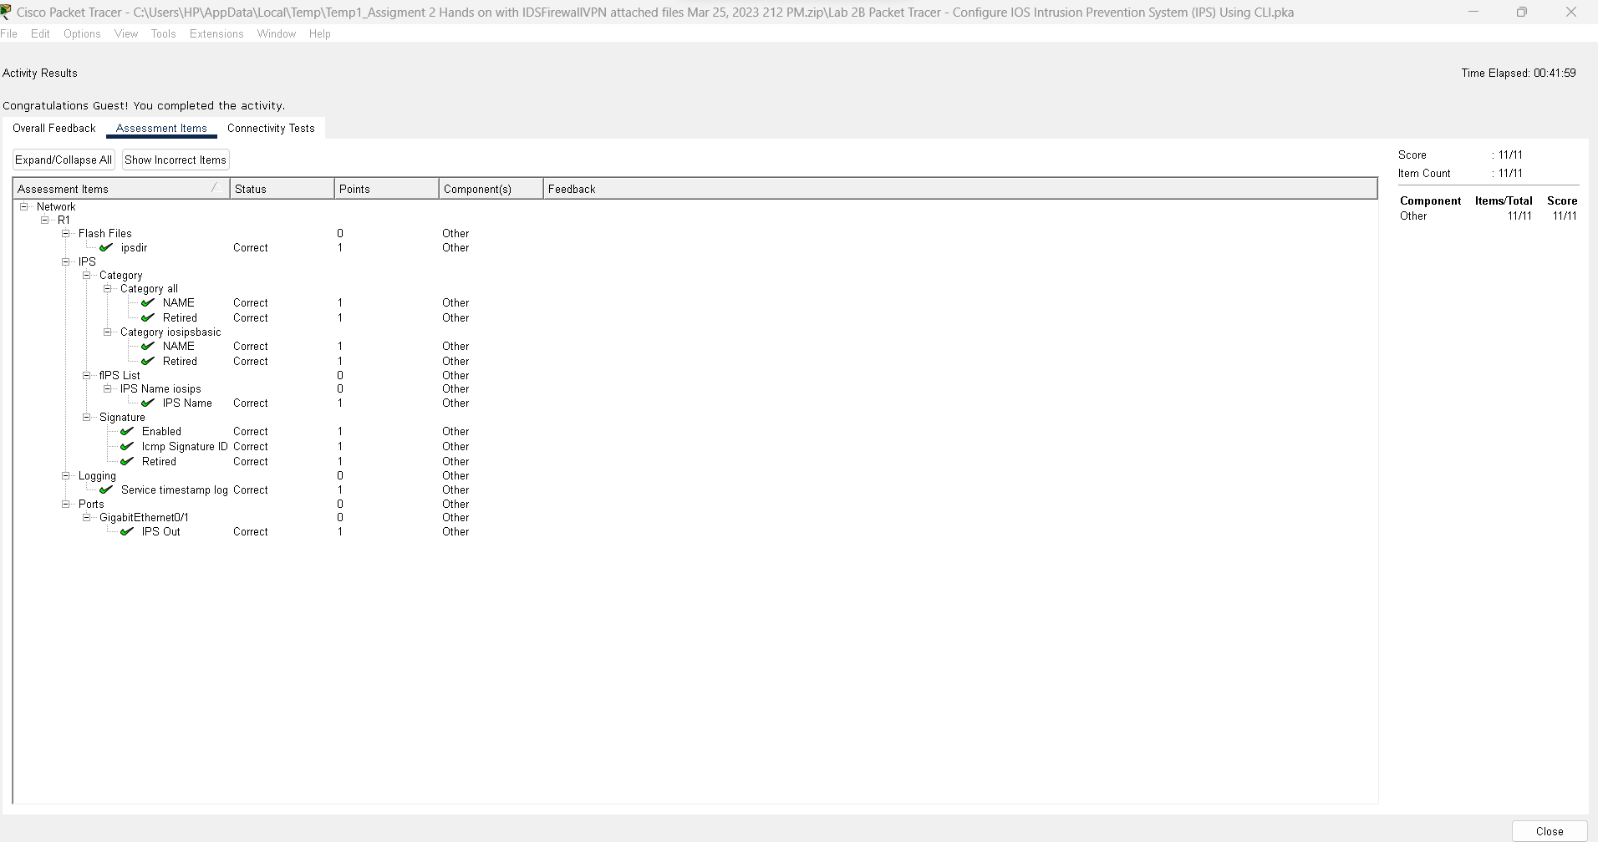

Using the order line Connecting point, we physically create the IOS IPS, log, modify an IPS signature, and confirm IPS in this lab (CLI). I developed the Interruption Counteraction Framework for Cisco IOS switches using the order line interface (CLI) of Bundle Tracer (IPS).

# 2C: Packet Tracer - Configure and Verify a Site-to-Site IPsec VPN Using CLI

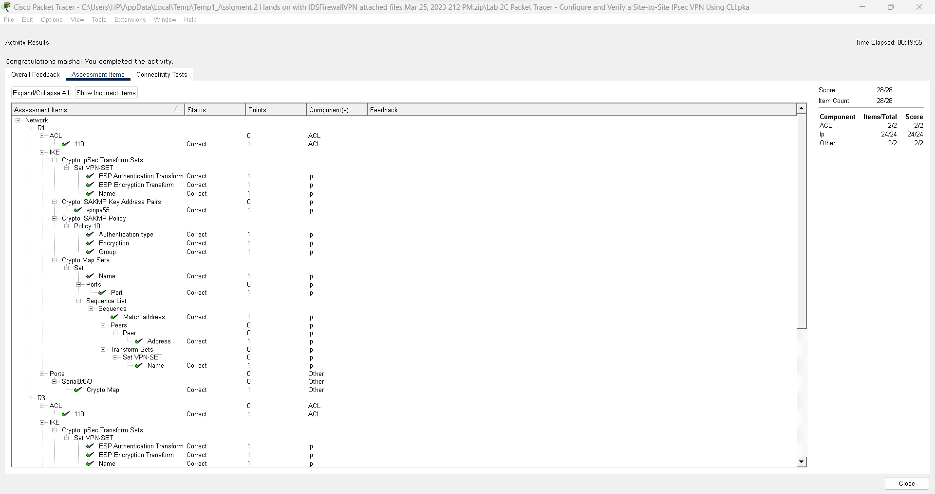

In this lab, in order to check and test network availability, we physically set up Web Convention Security (IPsec) rules, Virtual Confidential Organization (VPN) relationships, and CLI commands. In this lab, I learned how to create a stable and secure site-to-site VPN link between at least two businesses.